1. Draw the magnetic field that exists between [3]  
     
   1. Two North poles
   2. Two South poles
   3. A north and a south pole

1. Sketch the magnetic field in the plane shown for each case: [4]
2. A compass needle is placed due west of a vertical wire. A current flows through the wire. What is the direction of the current if:
   1. The compass needle points south **Up**_ [1]  
        
      and
   2. The compass needle points north _**Down** [1]
3. What is the direction of the magnetic field at :

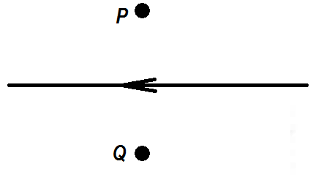

***I***

* 1. Point P **Into the page** [1]  
       
     and
  2. Point Q **Out of the page** [1]

1. 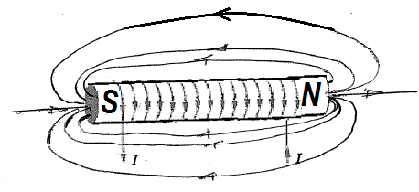Draw the magnetic field around the solenoid shown. Indicate the poles of the magnet formed. [2]

1. 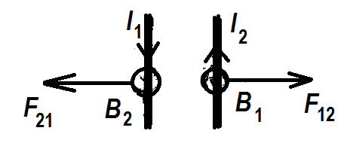Two long parallel wires carry equal currents in opposite directions. The magnitude of the force between the wires due to the currents is F. the separation between the wires is now doubled. The force between the wires due to the currents is now which of the following. [1]

$\frac{F}{2}and attractive$

$\frac{F}{2}and repulsive$

$\frac{F}{4}and attractive$

$\frac{F}{4}and repulsive$

Briefly explain your choice. [2]

**Magnetic field of I1 at I2 (B1) is out of the page. With I2 up, force on I2 (F12) is to the right. Magnetic field of I2 at I1 (B2) is out of the page. With I1 down, force on I1 (F21) is to the left. Hence force between wires is repulsive. The field strengths obey inverse square law, so doubling the distance will decrease the field and therefore the force by a factor ¼ .**

1. 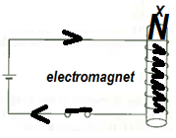The figure shows a solenoid wound around a core of soft iron to form an electromagnet.
   1. When will the electromagnet attract magnetic materials?   
      **When the switch is closed or turned on so that current can flow through the coil.** [1]
   2. How can the strength of the electromagnet be increased?

**Increase the number of turns wound around the soft iron.  
Increase the current through the coils by (increasing the battery voltage and/or reducing the resistance of the wires)**[2]

* 1. Show the direction of current flow when the switch is on. Will the end marked X become a north pole or a south pole? Briefly explain.

**North. By the right hand grip rule, the X end will be North as the right fingers grip around the direction of current.**

1. 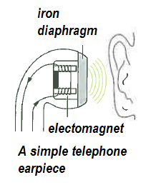The diagram shows a simple telephone earpiece or receiver. Explain how it works. [3]

**The receiver signal is converted to varying electrical current. The varying current is fed into coils that form an electromagnet. The magnet field produced by the electromagnet varies and changes direction. The varying magnetic field attracts and repels the magnetic diaphragm to various degrees causing the vibration that makes sound that the ear can receive and hear.**

1. 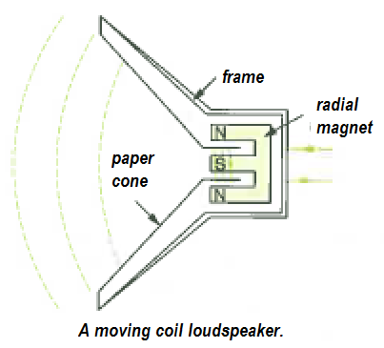The diagram shows a different simple telephone earpiece or receiver. Explain how it works. [3]

**The receiver signal is converted to varying electrical current. The varying current is fed into a coil attached to the paper cone and located between the radial magnets. The interaction between the magnetic field of the radial magnet and the varying magnetic field formed by the coil, produces varying force on the coil which vibrates carrying the cone with it. The vibration of the cone produces the sound that can be heard.**

1. 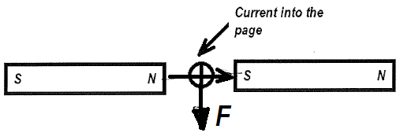The diagram shows a conductor carrying a current in a direction “into the page”.

* 1. What is the direction of the force on the conductor? **Down** [1]
  2. If the direction of the current is reversed, what is the direction of the force on the conductor? **Up**_ [1]
  3. How could the strength of the force on the conductor be increased using the same length of conductor and the same magnets? [2]  
     **F= ILB  
     Increase the current through the conductor  
     Bring the opposite poles of the magnet closer to increase the magnetic field B**
  4. How could the strength of the force on the conductor be made zero using the same length of conductor and the same magnets? [1]  
     **Reverse the poles of one of the magnets so that the opposing poles are both North or both South leading to zero magnetic field between them and hence zero force.**

1. The diagram shows a simple DC motor.
   1. 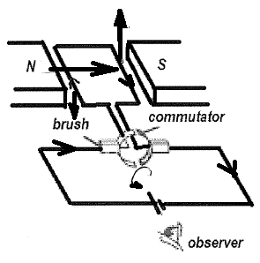What causes the coil in a DC motor to turn? How can the coil be made to turn faster? [3]

**The interaction between the magnetic field formed by the current through the coils and the magnetic field of the field magnets produce a force on the coils that generate a torque about the axis of the coil that causes the coil to turn.**

* 1. What is the direction of rotation of the motor as seen by the observer? [1]

**Anticlockwise**

* 1. What will happen to the direction of rotation of the coil if both the poles of the magnets and the polarities of the battery are reversed at the same time? [1]

**No change**

* 1. Describe the motion of the coils if the two ends of coil are connected directly to a battery without using the commutator and the brush. [2]

**Coil will rotate one way and as the side of the coils move to opposite poles of the magnet, direction of rotation changes to the other way. Coil will continue to flip/flop and will not complete any rotation.**

1. Which one of the following action(s) does not cause an induced emf to be set up in a coil of wire? Briefly explain your choice(s). [3]  
   1. Pushing a magnet into the stationary coil.
   2. Moving the coil over a stationary magnet.
   3. **Having a steady current flow through the coil.**
   4. Withdrawing a magnet from inside the coil.
   5. **Moving the coil and magnet at the same velocity.**

**c. There is a steady (non-varying) magnetic field linking the coils. An induced emf only occurs if the flux linking the coil varies. Since no variation in the flux linking the coils, induced emf is zero.  
e. Since both coil and magnet move at same velocity, no relative motion between them so no varying flux within coils therefore no induced emf.**

1. 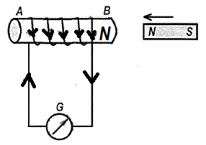A magnet is being pushed into a coil of wire which is connected to a galvanometer. Which of the following statements is/are correct? Briefly explain your choice(s). [3]  
   1. **The induced current will flow from A to B through the coil.**
   2. The induced current will flow from B to A through the coil.
   3. No induced current will flow.
   4. **End B will become a north pole.**

**As magnet is pushed in, the induced emf in the coil will produce a magnetic field at end B that will oppose the change producing it (Lenz’s Law). End B will need to be a North Pole. Induced current will then flow from A to B through the coil.**

14. The magnetic field strength inside a solenoid depends on the current through the solenoid. It also depends on factors such as the number of turns of wire in the solenoid, the length of the solenoid and the permeability of the medium inside the solenoid. The relationship between these various factors is:



where:

***B*** is the magnetic field strength in the centre of the solenoid (T)

***μ*** is the permeability of the medium inside the solenoid

***N*** is the number of turns of the solenoid

***I*** is the current in the solenoid (A)

***L*** is the length of the solenoid (m)

Some students devised an experiment to determine the permeability of air. They used a current balance apparatus to measure the magnetic field inside a solenoid for several different values of current. Their solenoid was 20.0 cm long and consists of 800 turns of wire.

Their results have been plotted on the graph below:

a) Draw in the line of best fit on the graph. [2]

b) Would you expect the line to pass through the origin? Explain. [2]

**Yes. The relationship is $B= \left(\frac{μN}{L}\right)I$. If B is plotted against I, a straight line should show with a gradient of $\frac{μN}{L}$ and an intercept of 0.**

c) What does the gradient of your graph represent? [2]

**The gradient of the graph will represent $\frac{μN}{L}$**

d) Use your graph to determine a value for ***μ*** (include the units for***μ***) [4]

**The gradient is $\frac{4}{0.79}=5.063 T.A^{-1}$; ∴ $\frac{μN}{L}=5.063$ $$so μ=\frac{L 5.063}{N}= \frac{0.2 5.063}{800}=0.00127 T.m.A^{-1}.turn^{-1}$$**

Answer: $0.00127 T.m.A^{-1}.turn^{-1}$

e) What effect would including a soft iron rod down the centre of the solenoid have on their results? Explain why. [3]

**The soft iron will intensify the magnetic field within the coil. For the same current and number of turns, B will be much higher, leading to a higher gradient, leading to a higher value for *μ.***

END OF PRACTICAL TEST